"Adriatic Voleyball Cup 2018
14.06-17.06.Kostrena/Croatia
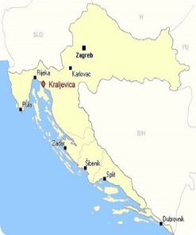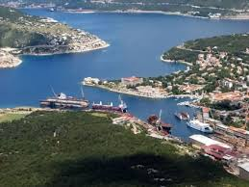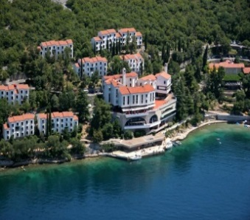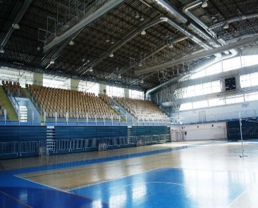
Croatia, City Kraljevica , Hotel Uvala Scott, Sport hall Kostrena
Dear young voleyball teams,
We invite volleyball teams at the first international summer volleyball tournament for the younger categories (male and female) on the Adriatic sea - Kvarner Riviera, near town Rijeka. All volleyball teams and their escorts will be located at the Hotel Uvala Scott 4 km from Rijeka airport. In the city sports hall in Kostrena, the games will be played simultaneously on two volleyball courts.
Tournament information::
N | Category | Born after 01.01. | Teams per category | Teams  per group | Game of  duration | Number of players in one  team | Number of games  (min - max)
1 | Female | 2002/03 | 8 - 10 | 4 - 5 | 3 sets | 6 | 5 - 6
2 | Male | 2002/03 | 8 - 10 | 4 - 5 | 3 sets | 6 | 5 - 6
3 | Female | 2004/05 | 8 - 10 | 4 -5 | 3 sets | 6 | 5 - 6
4 | Male | 2004/05 | 8 - 10 | 4 - 5 | 3 sets | 6 | 5 - 6
Tournament Proposals according to the rules of the Croatian Volleyball Association
• A maximum of 14 players per team
• PRIZES:
• Place 1-3 in every category, a cup per team, medal for each player
• Prizes for best player and shooters in each category.
HOTEL PRICE: 4-daily package per person in double room is 145 € per player to be paid in triple room is 132 € per person. Tourist tax of 12 -18 years 0,50 € per person, other persons older than 18 years pay 1 € tax. per day. Entry fee by one team: 100 €
FOOD DAY: Every day 3 meals + accommodation)
FIRST MEAL: Arrival - dinner at 14.06 (June) - Thursday.
LAST MEAL: Departure after lunch at 17.06 (June) - Sunday.
DEADLINE: 10 May 2018th (only if you stay a vacancy)
After your request for participation in the tournament, we will send you the application form and other information.
Our contact : globalsportevent@gmail.com info.mitteleuropa@gmail.com
Facebook: https://www.facebook.com/Adriatic-Volleyball-Cup-2018-790159501170148/

